WOONGJIN UV-Lamp Questionnaire
Customer Information date: / /
Company： | 。。。。。。。。。。 | Contact Person： | 。。。。。。。。。。
Fax： | 。。。。。。。。。。 | Tel No.： | 。。。。。。。。。。
E-mail： | 。。。。。。。。。。 | Mobile No.： | 。。。。。。。。。。
Address： | 。。。。。。。。。。。。。。。。。。。。。。。。。。。。。。
Post Code： | 。。。。。。。。。。
Remarks： | 。。。。。。。。。。。。。。：。。。。。：。。。：。。：。。。。。
Dear Customer:
For your interest in purchasing the product, we have to ask you to take a few minutes to help us fill the form below; that help us provide a more accurate with the lamp to you.
Lamps used in the brand and model：
What products used： 。。。。。。。。。。
Lamp No：。。。。。。。。。。。
Lamp Type：□High-pressure mercury lamp □Metal halide lamp □ExposureUV light
□Other
Overall length | (mm)
Arc length | (mm)
Diameter | (mm)
Wattage | (W)
Ampere | (A)
Voltage | (V)
Lead length | left mm right mm
Lead wire metal ring： | ○ Spade type ○ Ring type ○ other  ○ #8 ○ #10
O₃/no O₃： | ○ O₃ ○ no O₃
UV lamp ： | ○ Ceramics ○ Copper (If ordered a special lamp, please ask the manufacturer)
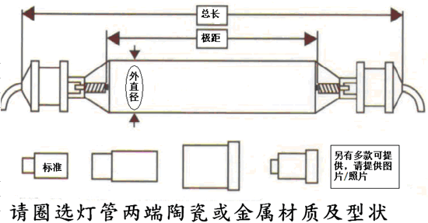
Arc length
Overall length
Diameter
standard
Another variety of available
Please provide photo
Please circle the tube ends of ceramic or metal material and shape

If you have any questions and contact
Please call +886-2-2999-1111 switch 2373. Or +886-2-8512-2479 (direct)
Contact Pro Accutech Co., Ltd. Business unit
Hing-Wah Mok manager or Zhenyi Yang Section Chief
+886-952-841-27
Fax +886 2 85122478 E-mail: alantlee@fourpillars.com.tw
Grateful if the completed application form and upload the inquiry to the contact window

South Korea WOONGJIN UV-Lamp professional manufacturer
Agent PRO ACCUTECH CO., LTD.
NO.14, Lane 61, Sec.1, Kuang Fu Rd., San Chung City,24112 Taipei, Taiwan, R.O.C.

